Accidents most commonly take place in moderate temperatures.

The number of traffic accidents peaks around rush hours: 8am and 5pm.

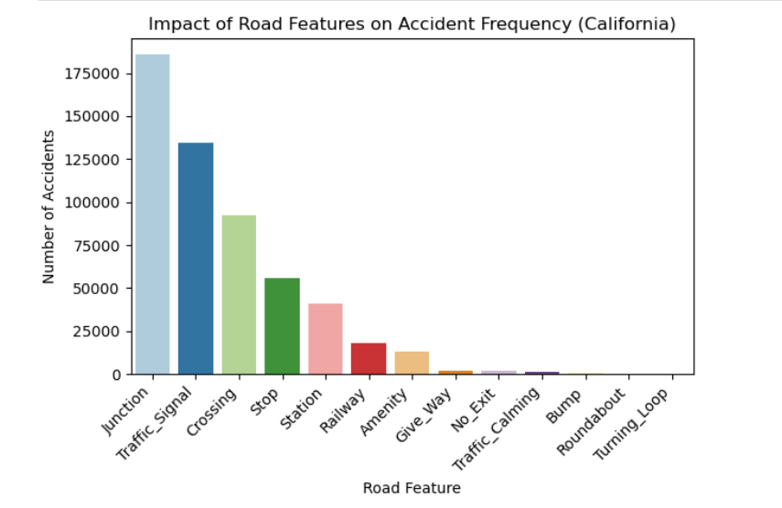

The highest number of accidents occurred on streets with junctions, traffic lights, crossings and stop signs.

The highest number of accidents occurred in the winter months.

Cities with the highest number of traffic accidents in California

Traffic accidents occurred most frequently in mild weather conditions.